Refer the “Migrate Data” section of DMS service in the AWS console.

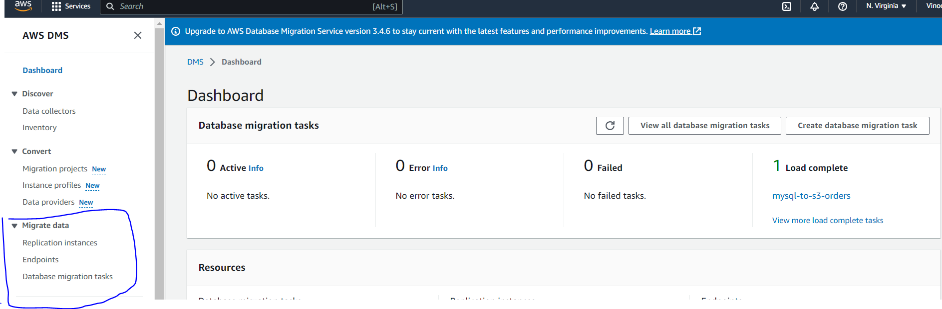

1. Create replication instance with single AZ for dev / test workloads and multi AZ for production loads.
2. Create a source endpoint to RDS MySQL database. Provide access information either through Secrets Manager or by manually entering the connectivity details.
3. Create a target endpoint to the Redshift cluster (ecommerce-cluster). Create a IAM role for AWS service DMS with required access to redshift.
4. Create a DMS task making use of the replication instance and the endpoints created above. Under Mapping Rules - Selection Rules - Choose schema name is like '%dev' and Source table name is like '%customers' to ensure only specific table is being moved.
5. In the “Task Settings”, go to the Editing Mode “JSON editor” and provide the target schema name.

Note that, we provide only the database server name and database name in endpoints.

The schema information for both source and target is provided in the task settings.

1. Enable pre-migration assessment if needed. Provide details of the S3 bucket/folder where the results of the pre-migration assessment need to be stored. Provide a IAM role that has required access to the S3 bucket/folder.
2. Once the pre-migration assessment has completed successfully, resume/restart the DMS task to actually move the customers data from MySQL to Redshift.
3. Once the DMS task completes, verify in Redshift if the customers data from MySQL is available in Redshift.

With this, we have copied the reference data to the target database successfully.